Name: Ali Hassaan Mughal
Regn No: 173627
Current IP address: 192.168.43.89
Lab Title: Introduction to the Network Layer

1.0 Objective of this lab:

In this lab, we’ll investigate the IP protocol, focusing on the IP datagram. We’ll do so by analyzing a trace of IP datagrams sent and received by the execution of the traceroute program. We’ll investigate the various fields in the IP datagram, and study IP fragmentation in detail.

2.0 Instructions:

- Read carefully before starting the lab.
- These exercises are to be done individually.
- You are supposed to provide the answers to the questions listed in this document (attach screen shots) and upload the completed report to your course’s LMS site.
- Avoid plagiarism by copying from the Internet or from your peers. You may refer to source/ text but you must paraphrase the original work. Your submitted work should be written by yourself.

4. IP fragmentation

4.1 Background:

IP fragmentation is an Internet Protocol (IP) process that breaks datagrams into smaller pieces (fragments), so that packets may be formed that can pass through a link with a smaller maximum transmission unit (MTU) than the original datagram size. The fragments are reassembled by the receiving host[1].

A maximum transmission unit (MTU) is the largest size packet or frame, specified in octets (eight-bit bytes), that can be sent in a packet- or frame-based network such as the Internet. The Internet's Transmission Control Protocol (TCP) uses the MTU to determine the maximum size of each packet in any transmission. Too large an MTU size may mean retransmissions if the packet encounters a router that can't handle that large a packet. Too small an MTU size means relatively more header overhead and more acknowledgements that have to be sent and handled. Most computer operating systems provide a default MTU value that is suitable for most users. In general, Internet users should follow the advice of their Internet service provider (ISP) about whether to change the default value and what to change it to[2].

In this part of the lab, we will try to find out what happens when IP fragments a datagram by increasing the size of a datagram until fragmentation occurs. We will ping with options (use the –s option on MacOS, -l on windows) to set the size of data to be carried in the ICMP echo request message. Note that the default packet size is 64 bytes in MacOS and 32 Bytes in Windows. Once you have send a series of packets with the increasing data sizes, IP will start fragmenting packets that it cannot handle.
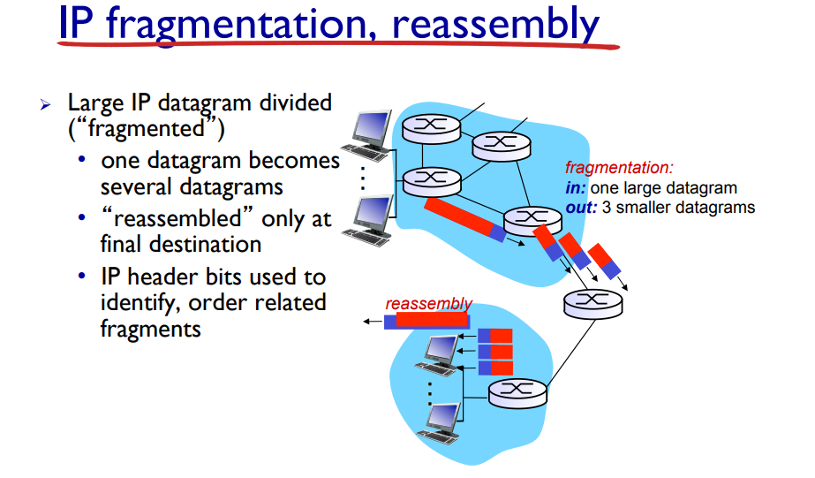
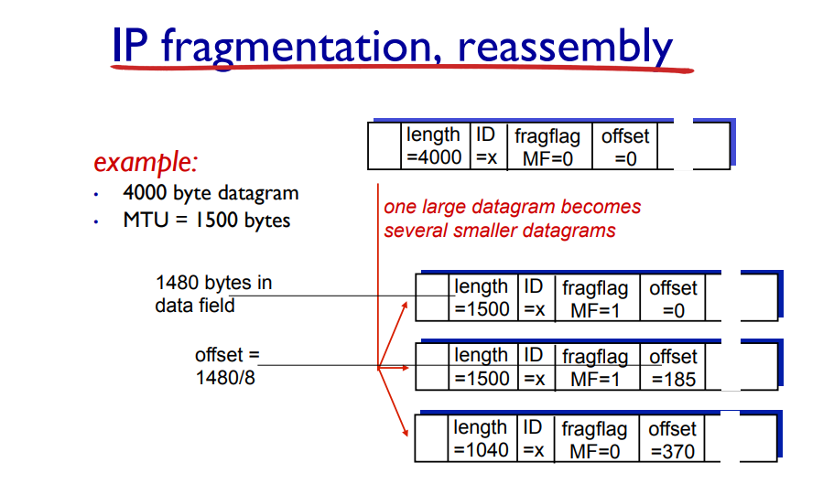
4.2 Steps for performing this part of the lab:

- Startup Wireshark and begin packet capture (Capture->Start) and then press OK on the Wireshark Packet Capture Options screen (we’ll not need to select any options here).
- Startup ping with default values to the target destination as 8.8.8.8
- Stop the wireshark capture when you receive at least 6 replies from target destination.
- Next, repeat the above steps by sending a set of ICMP requests with a length of 2000.
- Finally, repeat again with length value set as 3500

Now answer the following questions.

- Which datagram size has caused fragmentation and why? Which host/router has fragmented the original datagram? How many fragments have been created in this case?
According to the information from wireshark, the packets i.e. 2000 and 3500 have caused the fragmentation. The ethernet connection we are using has a limit of 1500bytes and has fragmented the original datagram so it makes 2 datagrams in case of 2000 and 3 in case of 3500.
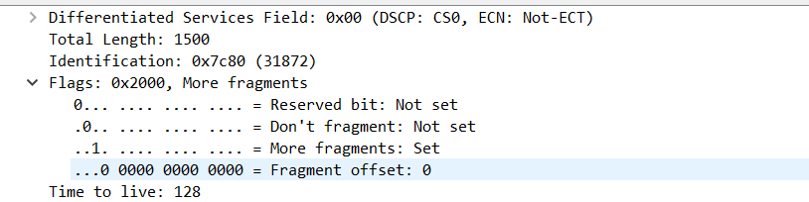

- Did the reply from the destination 8.8.8.8. for 3500 byte datagram also get fragmented? Why and why not?
Yes, it did get fragmented, because it also has to go through the internet link, and the routers have limits in terms of processing the datagrams i.e. in this case is of ethernet.
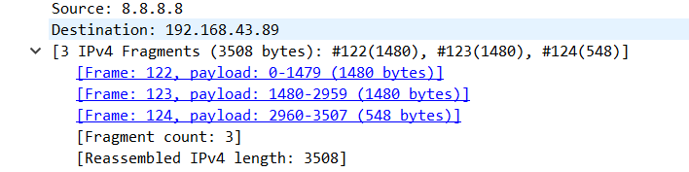

- Give the ID, length, MF and offset values for all the fragments of any single datagram with size 3500 bytes?
First Packet:
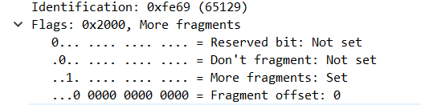
Second Packet:
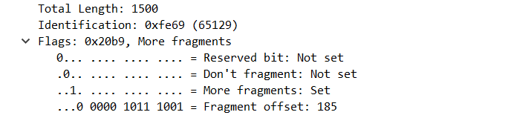
Third Packet:
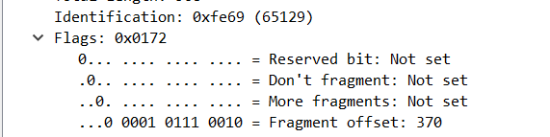

- Has fragmentation of fragments occurred when datagram of size 3500 has been used? Why and why not?
The fragments of fragments may have been formed in between, as we do not have complete information about the core, so if there is a PPP (Point to Point) layer whose fragment size is ~ 576 bytes so each fragment sized greater than that segment size i.e. ~ 576 bytes may be fragmented more.
So yes, they may be formed or may not be. Depending upon the internal structure of the routers i.e. they are Point to Point or 802.11 or Ethernet.

- What is the least MTU value along the complete path to destination? Which is the bottleneck link?
The MTU in the inner layer is unknown, as we do not know exactly is core Point to Point, 802.11 or Ethernet. As per, Ethernet is the one which is involved in the bottleneck of fragmentation which is shown as per the data.
But in case, in the core there is any PPP type of transmission, it may break the fragments into even smaller i.e. ~ 576 bytes fragments, that will be the bottleneck in this scenario.

References
[1] https://en.wikipedia.org/wiki/IP_fragmentation
[2] https://searchnetworking.techtarget.com/definition/maximum-transmission-unit

